OLVM – VM cpu type doesn’t match cluster cpu.

Current status of cpu properties :-

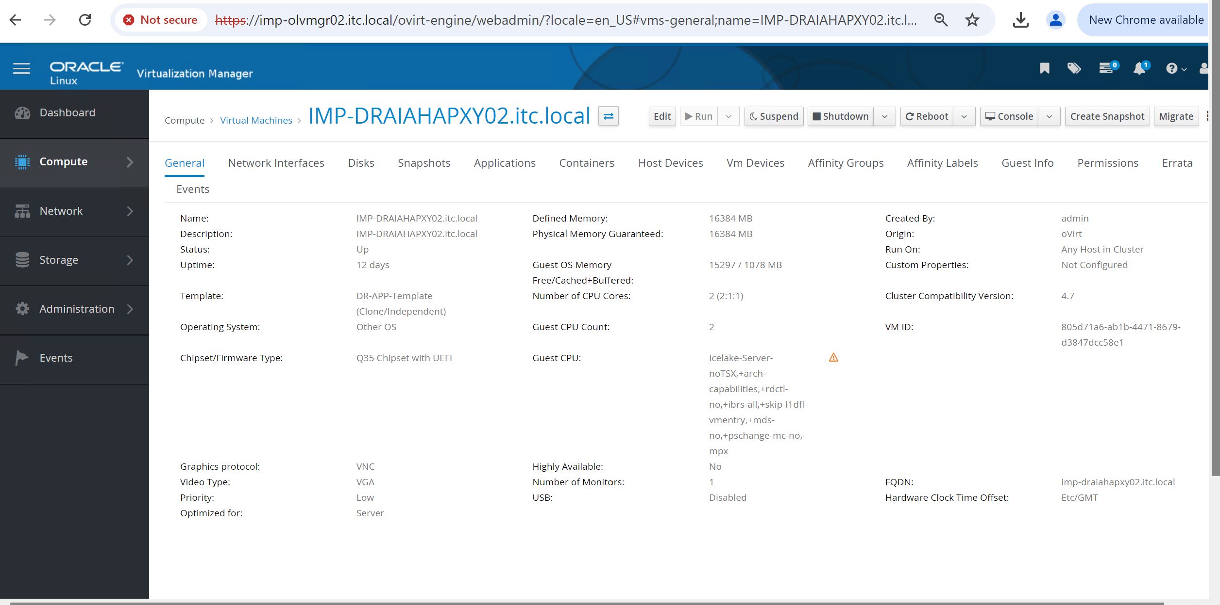

Guest cpu type to be modified to Icelake-Server-noTSX,-mpx
